**DATA STRUCTURES AND ALGORITHMS**

**EXERCISE 7: FINANCIAL FORECASTING**

**FinancialForecast.java**

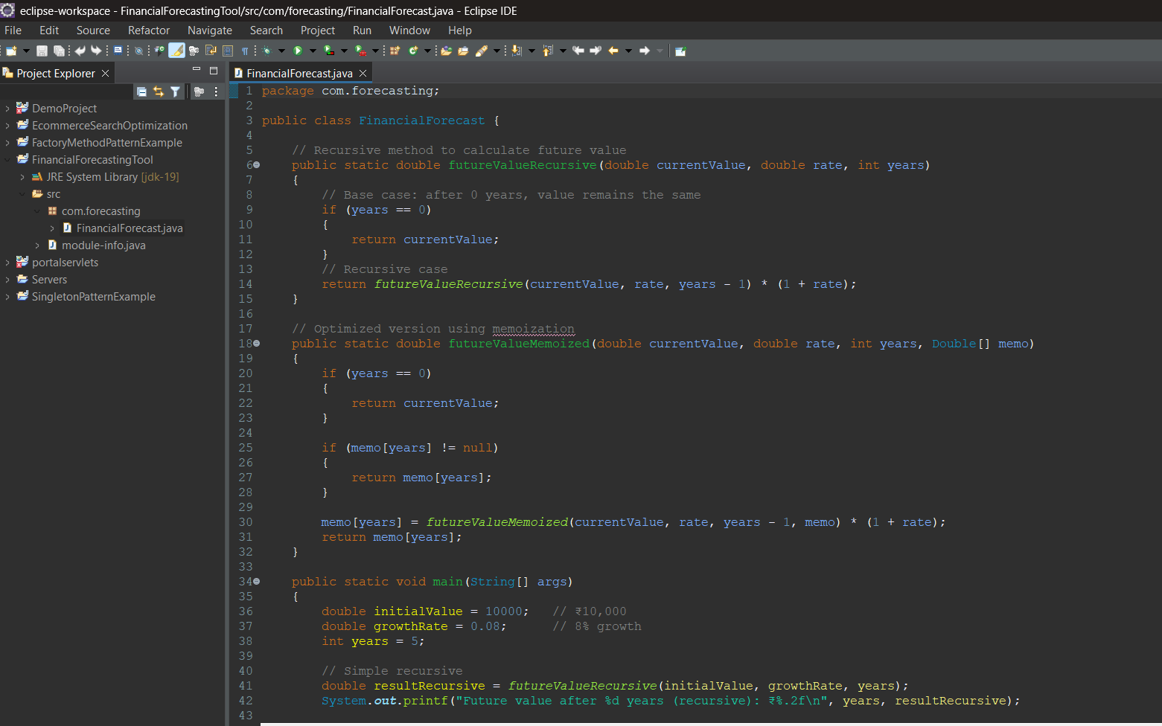

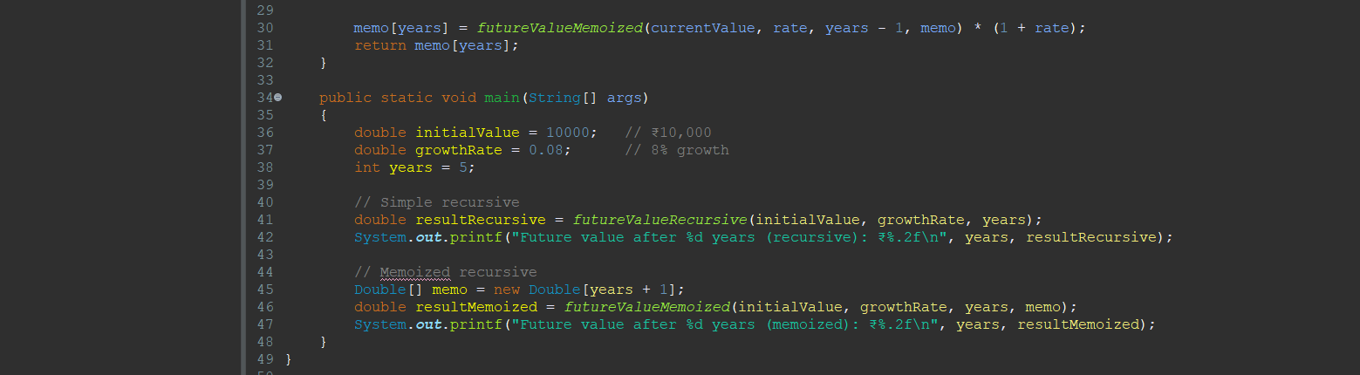

**Output:**

